SMART WATER SYSTEM

PROBLEM STATEMENT:

Limited groundwater, shortage in rainfall, and tremendous water consumption due to ever-increasing population have created water scarcity across the globe. Many countries are facing serious water shortage issues and desperately looking for ways to maximise water supply. To deal with this disastrous situation, many researchers are finding out alternate sources of potable water including solutions like artificial rainfall. But the real problem is, an effective solution is not yet readily available and some of the solutions like artificial rainfall are very costly and not practical to cover the rainfall across geographies. In such a case, it is more than necessary to focus on effective planning, control, and distribution of existing water resources available with mother earth.

Smart Water Management Systems can be a better solution to deal with a water supply and distribution issues. Smart Water Management Systems are however complex and costly to procure, operate and maintain. If we can find out a way to provide easy to develop, operate and maintain Smart Water Management systems at a reasonable cost then such systems can be deployed easily in various Smart Cities across various geographies. This will also highlight the importance of water conservation, and people can be sensitive enough while using the water.

An attempt is made through this paper to provide Smart Water Management System overview, its architecture, applications, and improvement areas. I hope that this paper will serve the purpose of promoting awareness about Smart Water Management System among various stakeholders of government bodies, urban planners, and Smart City professional.

BLOCK DIAGRAM:

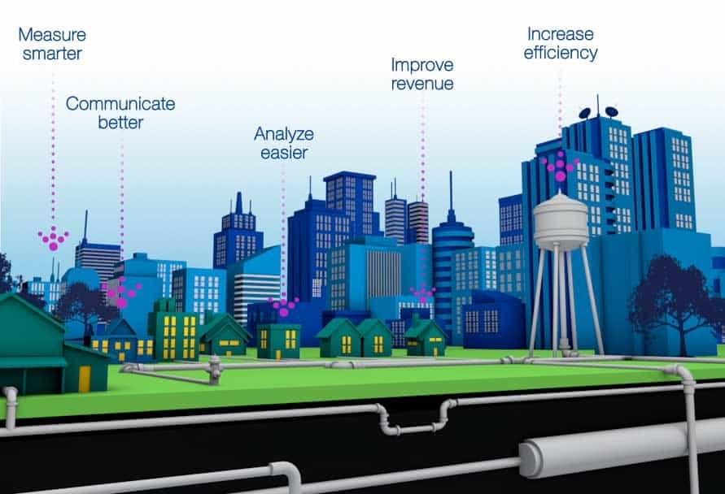

FLOW CHART:

